

**STANDARD OPERATING PROCEDURE**

**Do not Photocopy**

**Document Information Classification: Unrestricted**

|  |  |
| --- | --- |
| **Title:** | **ISMS Document Control** |
| **Effective Date:** | **18 Jul 2019** |
| **Reference Number:** | **SOP-02-01** |
| **Version Number:** | **3.7** |
| **Owner:** | **Document Management Process Owner,** |
| **Review Date:** | **08 Feb 2020** |

Table of Contents

1. Purpose 3

2. Scope 3

3. Responsibilities 3

4. Procedure 3

4.1. Document Creation 3

4.2. Document Content 4

4.2.1. Front page 4

4.2.2. Subsequent pages 4

4.3. Document Control 4

4.4. Document Numbering Convention 5

4.5. Document Approval 6

4.6. New Document Release 6

4.7. New Document Version Release 6

4.8. Document Compliance 7

4.9. Document Version Numbering 7

4.10. Document Review 7

4.11. Document Cross-references 8

4.12. Document Information Classification 8

4.13. Document Change Request 8

4.14. Document suspension or withdrawal 9

5. Cross-referenced ISMS Documents 9

6. Appendices 10

6.1. Q-Pulse Guidelines for Document Management 10

6.1.1. Reviewing a Document 10

6.1.2. Raising a Document Change Request 11

6.1.3. Responding to a Document Change Request 12

6.1.4. Creating a Draft Document from an Existing Version 14

6.1.5. Creating a New Draft Document (No Existing Version) 15

6.1.6. Editing Approval Workflow and Submitting Draft For Approval 17

6.1.7. Document Approval 18

1. Purpose

It is a requirement of the ISMS that policies for information are issued as a set of individual but related documents. These policies for information security should be reviewed at planned intervals or if significant changes occur to ensure their continuing suitability, adequacy and effectiveness. The purpose of this document is to define the procedure and method of control for creating, reviewing, maintaining and withdrawing this set of information security documentation.

1. Scope

The scope of this document covers the full document lifecycle including creation, naming, version control, approval, change, review, and withdrawal. The term “document” refers to items such as Standard Operating Procedures (SOPs), Process Maps, Forms, Policy and Guidance documents and Templates.

1. Responsibilities

The Information Security Manager (ISM) is responsible for:

* Co-ordination of the approval and release of all information security documentation.
* Managing the master list of documents including types, titles and reference numbers
* Approving major document releases

The Q-Pulse Administrator is responsible for:

* Activating (making ‘live’) approved draft ISMS documents
* Ensuring that the relevant members of staff are notified when new or revised ISMS documents are activated

Document Authors are responsible for:

* Using the templates for creating ISMS document drafts as available in Q-Pulse (prefixed ‘TEMP- within the Document module).
* Creating draft document versions.

Document Owners are responsible for:

* Reviewing their ISMS documents before the ‘Review Date’ or on an ad-hoc basis as requested by the ISSG or ISM
* Initiating the draft approval process and approving draft versions when required
* Responding to document change requests

1. Procedure
   1. Document Creation

Documents for new procedures, policies or process maps can be written by any member of staff but can only be approved for use by the process owner or the ISM. Once a new document is identified, the proposed title, which should relate to the content of the document, should be confirmed with the ISM who manages the document master list. The author will also notify the ISM of the nature of the document so that the document is allocated the correct document type, reference number and distribution list.

Information security documentation should be created using the relevant document template based on document type. If there is not an existing template, the author should consult with the ISM regarding the creation of a new template. Templates can be found on Q-Pulse with a document number prefixed by “TEMP-“.

* 1. Document Content

Documents created in MS Word will be presented in a standard ISMS format consistent with one of the ISMS document templates

* TEMP-01 Policy and Guidance document template
* TEMP-02 SOP document template
* TEMP-03 MAP Template
* TEMP-07 Form Template
* TEMP-08 Document Template for Publishing on Web
  + 1. Front page

The information to be included on the cover page is:

1. Title (of the document)
2. Effective Date
3. Document reference number
4. Version number
5. Owner (not required for web publishing)
6. Review Date (not required for web publishing)
   * 1. Subsequent pages

The subsequent pages will include (if applicable):

1. Header: containing HeRC logo, document type (e.g Standard Operating Procedure), document reference number, document title, page numbering, effective date and version.
2. Purpose: the reason why the document exists
3. Scope: What the document applies to, including any specific examples
4. Responsibilities: Individuals and/or groups and their responsibilities specific to the policy or procedure. This should only include responsibilities that are in addition to the standard responsibilities (see ISMS-02-07 Roles and Responsibilities). The activities for any specific responsibilities should be also be described in the detailed document procedure.
5. Procedure or Policy or Map: detailed instructions on how to do something, a process map or policy
6. Cross-referenced ISMS Documents
7. Appendices: containing examples of forms, diagrams and any additional information that is not included in the text.
   1. Document Control

All draft and current documents will be maintained on Q-Pulse and will be made available to staff as required for their role through a Windows client or web interface. Obsolete and suspended documents will remain in the document module of Q-Pulse but will not normally be available to staff.

Working copies of documents must not be kept for longer than needed. Printed or locally stored versions of documents are uncontrolled and may be out of date; therefore, the latest Q-Pulse version should always be used when following a procedure.

* 1. Document Numbering Convention

The following document numbering convention will be used.

**[Document Type]* - [ISMS Category sequence number]** - [Document Index] e.g. ISMS-03-01**

*Document Types:

|  |  |
| --- | --- |
| **Document Type** | **Document Type description** |
| SOP | Standard Operating Procedure (Usually MS Word) |
| MAP | Process Map (often a workflow diagram) (Usually MS Word with embedded MS Visio object) |
| ISMS | Policy and Guidance (Usually MS Word, and sometimes MS Excel) |
| TEMP | ISMS Document Template (MS Word template for each of the above 3 document types) |
| FORM | Form (Usually an MS Word document that needs to be completed, signed and returned by a user of the TRE) |
| DIAG | Diagram (usually a pdf) e.g. network schematic |
| REC | Record of system settings or operations (usually a .log or MS Excel) e.g. backup records |

**ISMS Category sequence number:

|  |  |  |
| --- | --- | --- |
| **ISMS system number sequence and category** | | **Related TRE staff groups/teams** |
| 00 | ISMS Implementation | All |
| 01 | Personnel and Training | All |
| 02 | ISMS Management | All |
| 03 | TRE Operations | TRE Operations |
| 04 | ISMS Improvement | All |
| 05 | Asset and Supplier Management | TRE Operations/CHI Staff Administration |
| 06 | Information and Physical Security | TRE Operations |
| 07 | ISMS Governance | ISMS Mgt Team/TRE Operations |
| 08 | Communications | CHI Operations |
| 09 | TRE System Administration | TRE Operations |

The Document index numbers start with ‘00’ and are allocated to each document at the point of creation (managed by Q-Pulse). So the first document of a particular category is assigned ‘00’, then the next to be created is assigned ‘01’ and so on.

Two examples of the above combined document number system are included below:

* The third document created that provides guidance (policy) about ‘ISMS improvement’ will be assigned ‘ISMS-04-03’.
* The first document created that provides a procedure for operations will be assigned ‘SOP-03-00’.
  1. Document Approval

All major versions of documents should be approved in Q-Pulse before release. A minimum of one approver is required for a major document release. If the process owner is adding the new document record the mandatory approver should be the ISM. If the Q-Pulse administrator is adding the new document record the mandatory approver should be the process owner.

Exceptions to this are where the ISM is also the process owner in which case no further approval is required. The ISM may also move any document to an “Active” state without formal approval from the process owner. The release of a minor version of a document does not require formal approval and these versions may be implemented by the ISM or Q-Pulse administrator.

* 1. New Document Release

The procedure for a new document release is as follows:

* The author will identify the ISO controls that are to be addressed by the new document and arrange to update the Controls Statement of Applicability (ISMS-02-11) as appropriate.
* The author will also identify the groups that will be required to read or have access to the document (also managed in ISMS-02-11).
* The draft document is prepared and reviewed outside of Q-Pulse. When the final draft version is ready it is emailed to the process owner or Q-Pulse administrator by the author
* The process owner or Q-Pulse administrator generates a draft document record card in the Documents module of Q-Pulse
* All relevant sections of the record card should be completed and the draft document attached.
* The approval template should be amended to establish the people that must review and approve the document before activation and release.
* The draft can then be issued for approval.
* Approvers must respond to the approval notice with either “approve” or “reject”. Comments supporting the response should also be included. If further detail is required this should be provided to the process owner so that a new version can be prepared and redistributed for approval.
* Once all approvers have responded with “approve” the Q-Pulse administrator will activate the draft document in Q-Pulse and ensure that it is distributed to the correct users.
  + Once activated, Q-Pulse updates all users on the distribution list to indicate on their Launchpad that there is a new document for acknowledgement.
* Note: If any user retraining is required before full activation of the document, a ‘Draft Approved’ document status is available. Any requirement to use this status should be confirmed with the Q-Pulse system administrator prior to document approval.
  1. New Document Version Release

The procedure for a new document version release is similar to the process for a New Document Release.

* The author will identify if there are any changes to the ISO controls that are addressed by the new document version and arrange to update the Controls Statement of Applicability (ISMS-02-11) as appropriate.
* The author will also identify any changes to the groups that will be required to read or have access to the document (also managed in ISMS-02-11).
* The draft document is document is prepared and reviewed outside of Q-Pulse and then emailed to the process owner or Q-Pulse administrator by the author
* The process owner or Q-Pulse administrator generates a new draft document for approval from the existing record card of the document.
* Some details for the document will be pre-populated by Q-Pulse including: Type, Number, Revision and Title.
* Q-Pulse will automatically set the next revision number for a minor release. For a major version release the revision number should be updated as per the guideline in section 4.9.
* The Confirm Approvers template should be amended to establish the people that must review the document before activation and release.
* The draft document should be attached to the record card.
* This will present the draft document record where the Change Details must also be added and the record re-saved.
* The draft will be issued for approval and the remainder of the process is identical to the process for a New Document Release (see ** in section 4.6).
  1. Document Compliance

After a major version of a document has been released or amended the relevant managers need to ensure that their teams are compliant by checking that any changes are followed by their team, and that all relevant staff have acknowledged the version of the document on Q-Pulse. Compliance will be checked via the internal audit process.

* 1. Document Version Numbering

All new active documents will be numbered as version 1.0.

Minor revisions shall be used to indicate where small changes have been made to active documents such as formatting, spelling or grammar corrections, or where changes have been made that do not require further approval or acknowledgement. Minor revisions shall be indicated by making increments to the decimal place of the version number e.g. V 1.2; V 1.3; V1.4.

Major revisions shall be used where the active document has had significant process changes and requires re-approval. Major revisions shall be indicated by making increments to the whole number e.g. V 1.0; V 2.0; V 3.0.

* 1. Document Review

All ISMS documents will be reviewed for relevance and content by the process owner at least every two years, or on an ad-hoc basis as requested by the ISSG or ISM. Q-Pulse stores the due date for reviews on the document record card. To complete a review a Review record should be created from within the Review History section of the document record.

Where documents primarily exist to link to externally hosted content not managed by CHI the review period will be set at 6 monthly intervals to ensure the links are regularly verified. The documents managed in this manner are:

* ISMS-02-03 - Index of relevant policy

A review can be completed by a single person although if multiple reviewers are required these can be added to the detail of the Review record. Q-Pulse will indicate to users where any reviews are outstanding. Once a review is performed, the reviewer will decide whether the document requires change or not and raise any change requests as necessary.

The outcome of reviews should be categorized as follows:

* **Major Change** – Change Request (CR) has been raised. A significant change is required that changes the existing process and would require staff to review their tasks and responsibilities.
* **Minor Change** - There may be some minor changes identified which do not warrant a CR e.g. a typographical error. These minor change details should be identified in the Review comment.
* **No Change** – The review has identified that no changes are required.

Once the review is complete, Q-Pulse will be updated to reflect the next review due date. Review dates will only be updated on the release of major versions (i.e. V 2.0, V 3.0) or where the review has confirmed that no significant changes to the document are necessary. Records of all reviews are available on each document record card.

* 1. Document Cross-references

ISMS document cross-references will be managed using the Related Documents property in Q-Pulse. These can be automatically displayed in the document section “Cross-referenced ISMS documents” using the Q-Pulse Word plug-in office tag “Related Documents”.

In-text document references should include the document number to identify the document. e.g. “as described in the SOP for document control (SOP-02-01)".

Cross-references to documents will remain valid for minor revisions e.g. a cross-reference to version 1.0 of a document will also remain valid for version 1.1, 1.2 etc. Cross-references should be reviewed when a major revision of a referenced document is released.

* 1. Document Information Classification

All ISMS documents will be classified as unrestricted unless otherwise stated on the first page of the document. The ISSG will advise as to which documents should be classed as restricted or highly restricted and these documents will clearly be marked as such.

* 1. Document Change Request

Any process owner or auditor may request a change to a document via a Q-Pulse Change Request. These should only be raised for a process change or significant change to document content such as scope or purpose. Change Requests should not be used for minor document corrections such as typographical errors. In the Q-Pulse Windows client the change request wizard is available in the document module and can be accessed from the document record card. In the Q-Pulse Web Interface the change request dialog can be accessed by clicking theicon adjacent to the document record. The user can enter the required change and add an attachment if necessary. For major changes (e.g. process change) the process owner will then respond to the change request by indicating their approval or rejection of the change. For minor changes the change may be accepted by the process owner, ISM or Q-Pulse administrator. If approved, the change may be made immediately or following the next review of the document.

All changes should be assessed within 14 days to confirm whether the change is accepted or rejected.

* 1. Document suspension or withdrawal

Documents may be withdrawn or suspended for a number of reasons, as detailed in the following section:

* Document suspension: A document may no longer be involved in current working processes although it could be re-instated if the process comes back into use.
* Document withdrawal: A document may be withdrawn if it is superseded by a new version or if the procedure becomes obsolete.

1. Cross-referenced ISMS Documents

|  |  |  |
| --- | --- | --- |
| Number | Type | Title |
| ISMS-02-11 | ISMS\Policy & Guidance\ISMS Management - policy & guidance | Controls Statement of Applicability |
| ISMS-02-07 | ISMS\Policy & Guidance\ISMS Management - policy & guidance | ISMS Roles and Responsibilities |

1. Appendices
   1. Q-Pulse Guidelines for Document Management

Process owners have high-level document responsibilities in Q-Pulse including creating draft documents, reviewing documents and responding to change requests. Process owners do not have the ability to delete any records or make draft documents active. This appendix describes in further detail the Q-Pulse steps necessary to complete these responsibilities. Note: This guideline only describes the use of the toolbar icons to complete the Q-Pulse actions. All of these actions may also be completed using menu bar items.

* + 1. Reviewing a Document

Document reviews are performed in the Review History section of the document record card.

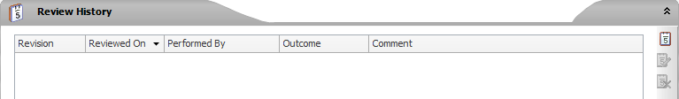

* After reviewing the document, the process owner should record the review by clicking the  icon which will display the following dialog:

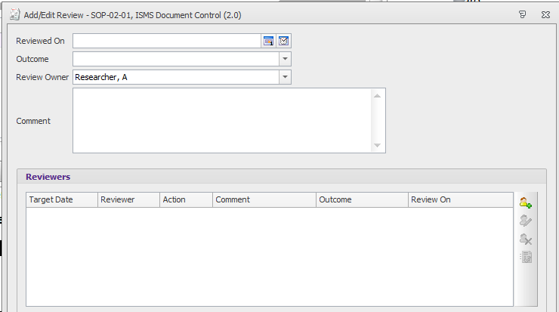

* Record the outcome by selecting the appropriate response from the drop down list:

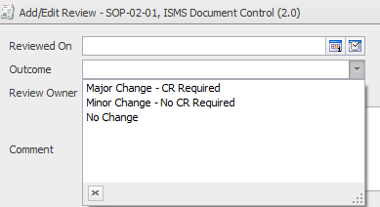

* Click OK to complete the review. Q-Pulse will automatically update the review due date.
* If changes are required to the document the Process owner is also required to raise a change request on the document.
* Additional reviewers can be invited to review the document before the overall review record is completed by clicking on the  icon. This opens the following dialog where the additional reviewers can be selected.

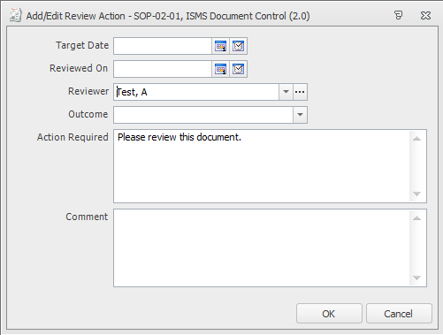

* On clicking OK the invited reviewer will receive a notification in their action list.
  + 1. Raising a Document Change Request

Change requests may be raised against any document in the document register. The process owner will have to approve any request and may choose not to implement some.

* Highlight the document you want to raise the change against on the document list view
* Click  on the toolbar. This icon can also be accessed from the document’s record card.
* Enter the details of the change request and attach any supporting information.

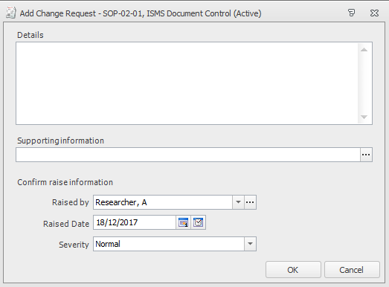

* Click OK to notify the document owner.
  + 1. Responding to a Document Change Request

Process owners are responsible for responding to change requests.

* Q-Pulse will notify the appropriate process owner when a change request has been raised.
* The process owner should navigate to the document record where the change request can be found.

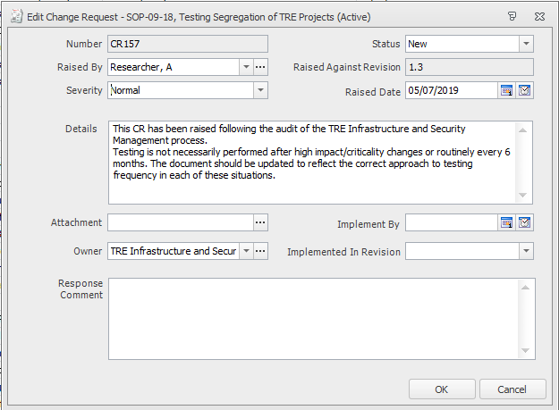

* The process owner shall read the change request and any attachments and decide if the change request is appropriate.
* The process owner will then change the status of the change request to Accepted or Rejected.

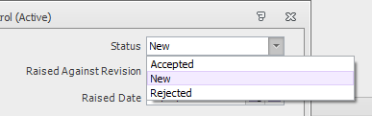

* A response comment will also be required for either response. Comments should include reasons for not accepting the request or a statement of when the change request will be implemented e.g. this change request is not urgent and will be implemented when the document is next revised.
* Click OK to close the window.
* The process owner shall commence the draft document process if the document requires immediate update. Other less urgent change requests may wait until the document is next revised.
  + 1. Creating a Draft Document from an Existing Version
* A draft document is created from with the document record by clicking on the  icon on the toolbar and selecting the ‘Draft (Using Approval)’ option from the dropdown. This will start the Wizard and display the following dialog.

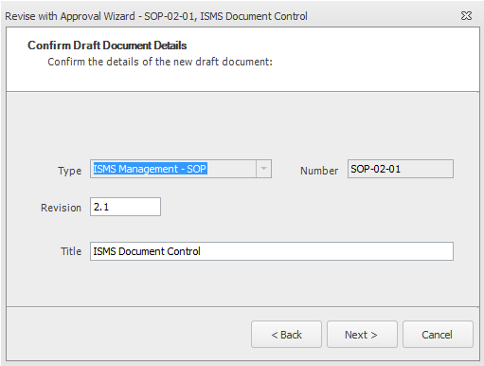

* Confirm the proposed revision number is correct. For a minor version release the correct number should be presented. For a major version release the revision number can be overtyped.
* Click on ‘Next’ to display the ‘Confirm Approvers’ dialog. Add or confirm (if already listed) any approvers needed for this version of the document. Use the icon to add new users.

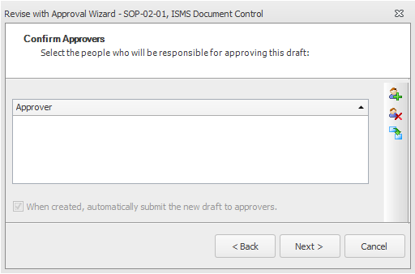

If the  box is ticked the document will automatically be circulated to approvers when the draft record is created. If this box is unticked the document can be circulated for approval at a later date using the  icon.

* Click on ‘Next’ to display the following dialog where you can attach the updated draft document to the document record.

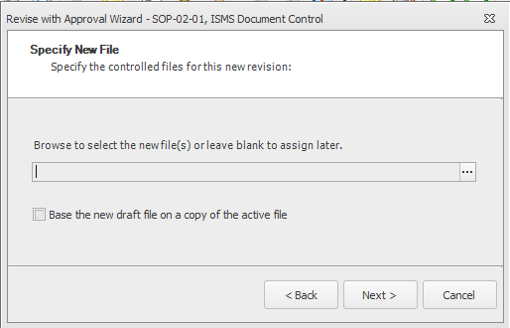

* Complete the Wizard by clicking on the ‘Next’ and then ‘Finish’ buttons.

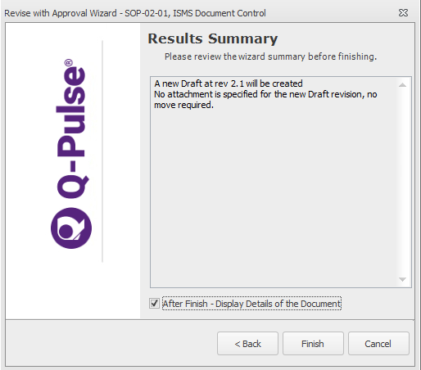

* + 1. Creating a New Draft Document (No Existing Version)
* A completely new draft document record is created from the Document List screen.
* Select the ‘New’ icon and select Document -> Draft document from the dropdowns.

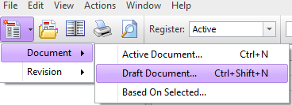

* This displays the new document record card where the document details can be added.

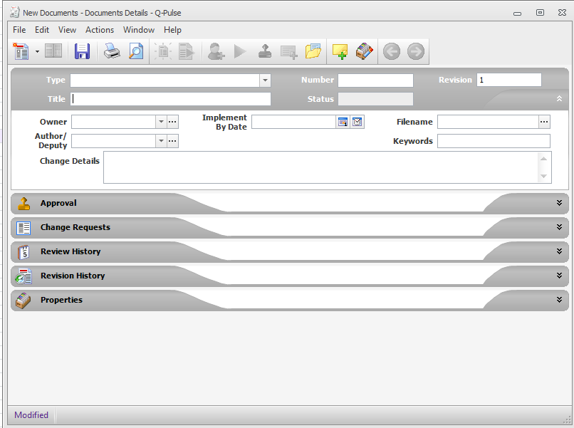

* All relevant sections of the record card should be completed including:
  + **Type**: The document type selected from the dropdown. This should have been previously agreed with the ISM.
  + **Number:** The document number will be automatically generated by Q-Pulse when the document type is selected. Note: the document number may be edited if required; however, it should follow the agreed numbering convention (see section 4.4).
  + **Revision**: New documents should have a revision of 1.0.
  + **Title**: The name of the document (as confirmed with the ISM).
  + **Status**: This field will be automatically populated. It will be either Active or Draft. Note: all new documents should be created as a draft and then activated after approval unless an exception has been agreed with the ISM.
  + **Owner**: The person with overall responsibility for the document – i.e. the process owner.
  + **Author** (optional): The person who created the document.
  + **Change details**: For a new document this will say “First version”. For subsequent versions identify the key changes that have been applied to this draft version.
  + **Keywords** (optional): A section of words that are not found in the document title or name, which may be useful when searching for the document. or on an ad-hoc basis as requested by the ISSG or ISM
  + **Related Documents** – This allows documents referenced by the new draft to be associated with the document. This section is found in the properties tab of the record card and should be used to electronically link the new document to existing ISMS documents.
  + **Implement Date** and **Keywords -** are optional and can be left blank.
* The draft document can be attached to the record card by selecting “Filename” to browse for the file. This opens the ‘Edit Attachment’ window and ‘Add Files’ will access file manager to locate the file. The link to the file can be edited by changing the ‘Attachment Description box; this is recommended if the file name is not the same as the document title.

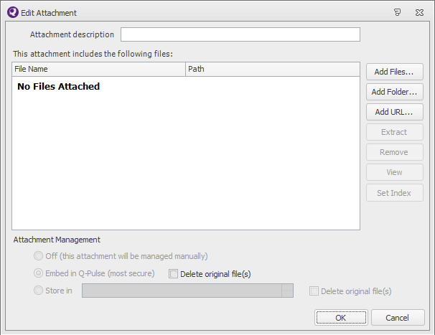

Note: if the ‘Delete original file’ box is ticked the original file will be removed from your local folder.

* + 1. Editing Approval Workflow and Submitting Draft For Approval
* To edit the approval workflow the ‘Approval’ tab can be expanded and users added as described in section 6.1.4. using the  icon.

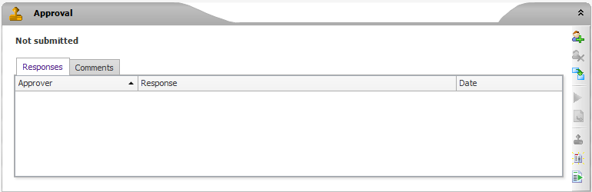

* The draft can be issued for approval by clicking the  icon. This will start the ‘Submit for Approval’ wizard.
* If it is necessary to draw the attention of the approvers to specific sections of the revised document the ‘Comment’ can be updated as appropriate.

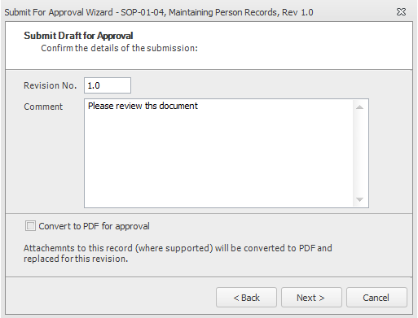

* Q-Pulse will create approval actions for the approvers in the order they appear in the approval workflow.
  + 1. Document Approval
* Users will notified of an invitation to review a document on their LaunchPad

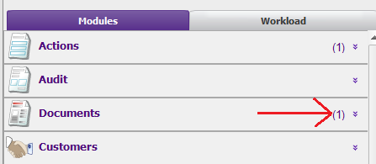

* This will also be indicated in the My Actions window in the Document List

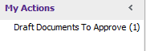

* Clicking on the action will list all documents awaiting approval.
* Open the document record and the document to review the content.
* When the review is complete navigate to the ‘Approval’ tab.

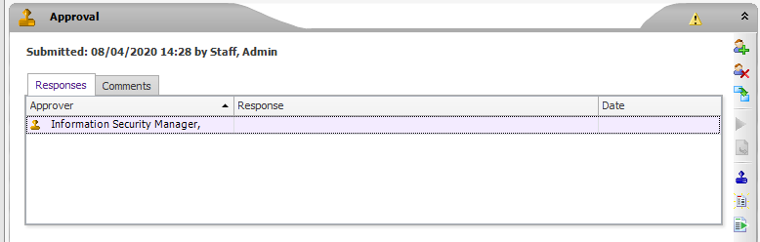

* Add approval response by clicking on the  icon

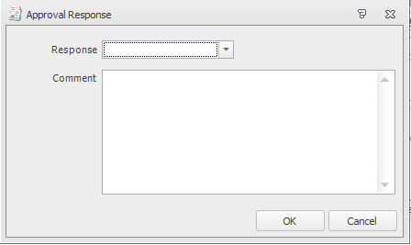

* OK the response and save the document record.